ASSIGNMENT 1
Java Fundamentals — Student Profile and Basic Calculator
Unit 1 – Introduction to Java | Individual Coding Assignment

Student Name | Sasanka Sekhar Kundu
Assignment | Assignment 1 – Java Fundamentals
Program | Student Profile and Basic Calculator
Programming Language | Java

1. Objective
The objective of this assignment is to understand the basic structure of a Java program, declare variables using suitable primitive and reference data types, perform arithmetic operations, and display formatted output using System.out.println(). The program also demonstrates how to compile and execute a Java program using the terminal.

2. Problem Statement
Develop a Java application that displays a student's basic profile information and performs addition, subtraction, multiplication, and division on two numbers. The results must be displayed in a clear and readable format.

3. Technologies / Concepts Used
- Java programming language
- Class and main() method
- String and int data types
- double data type for decimal division
- Arithmetic operators: +, -, *, /
- System.out.println() for formatted console output
- javac compiler and java runtime command
- Visual Studio Code as the IDE

4. Source Code
public class StudentProfileCalculator {
public static void main(String[] args) {
// ===== Student Profile =====
String name = "Rahul Sharma";
int rollNo = 101;
String course = "B.Tech Computer Engineering";
String year = "Second Year";
// ===== Calculator Values =====
int firstNumber = 25;
int secondNumber = 10;
// ===== Arithmetic Operations =====
int addition = firstNumber + secondNumber;
int subtraction = firstNumber - secondNumber;
int multiplication = firstNumber * secondNumber;
double division = (double) firstNumber / secondNumber;
// ===== Display Student Profile =====
System.out.println("===== Student Profile =====");
System.out.println();
System.out.println("Name : " + name);
System.out.println("Roll No : " + rollNo);
System.out.println("Course : " + course);
System.out.println("Year : " + year);
// ===== Display Calculator =====
System.out.println();
System.out.println("===== Calculator =====");
System.out.println();
System.out.println("First Number : " + firstNumber);
System.out.println("Second Number : " + secondNumber);
System.out.println("Addition : " + addition);
System.out.println("Subtraction : " + subtraction);
System.out.println("Multiplication : " + multiplication);
System.out.println("Division : " + division);
}
}

5. Explanation of the Program
Class: StudentProfileCalculator is the main class that contains the application.
main() method: The main() method is the entry point from which Java begins program execution.
Student variables: String is used for name, course, and year, while int is used for the roll number.
Calculator variables: The two input numbers are stored as int values: 25 and 10.
Arithmetic operations: The program uses +, -, *, and / to calculate the four required results.
Division: The division result is stored as double and firstNumber is cast to double so that 25 / 10 produces 2.5 instead of integer result 2.
Output: System.out.println() displays the student profile and calculator results with meaningful labels.

6. Compilation and Execution
The program was successfully compiled and executed from the terminal using:
javac StudentProfileCalculator.java
java StudentProfileCalculator

7. Program Output
===== Student Profile =====
Name : Rahul Sharma
Roll No : 101
Course : B.Tech Computer Engineering
Year : Second Year
===== Calculator =====
First Number : 25
Second Number : 10
Addition : 35
Subtraction : 15
Multiplication : 250
Division : 2.5

8. Execution Screenshot
The following screenshot shows the Java program in Visual Studio Code and the successful terminal execution with the Student Profile and Calculator output.
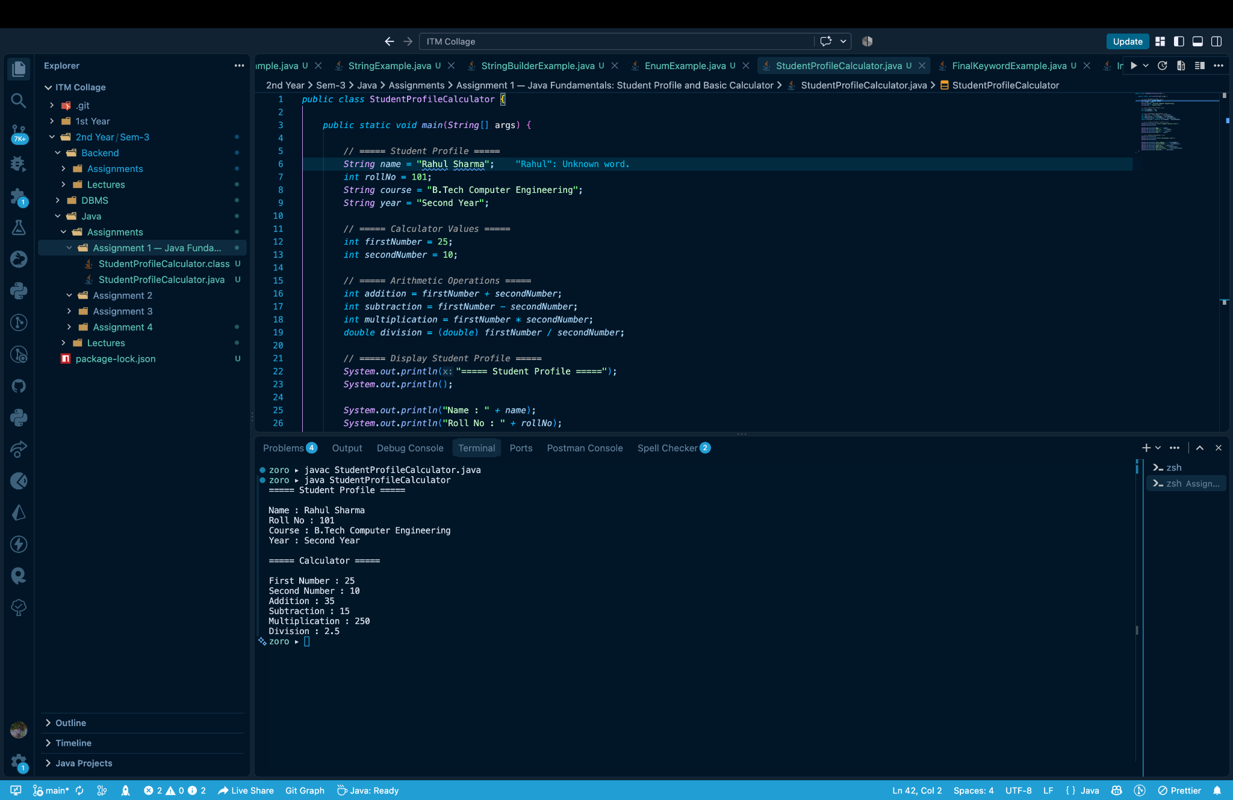

9. Result
The Java program was successfully compiled and executed. It correctly displayed the student profile and calculated addition, subtraction, multiplication, and decimal division for the given numbers. The expected division result of 2.5 was preserved using the double data type.

10. Conclusion
This assignment provided practical experience with the fundamental structure of Java programs, variable declaration, data types, arithmetic operators, console output, compilation, and execution. The successful terminal output confirms that the implementation meets the stated requirements.

— End of Assignment 1 Report —

